Stakeholder workshop on Women’s, Children’s, Nature’s Rights in Environmental Governance Report

14 October 2022

Introduction

The Southern and Eastern African Regional Centre for Women’s Law (SEARCWL) under the Faculty of Law University of Zimbabwe held a half day stakeholders workshop on the 14th of October 2022. The purpose of the workshop was as follows:

- To discuss the draft curriculum for the WCNREG Masters Programme
- To dialogue and have an Interactive and open discussion and input on critical issues that need to be addressed in the programmme.
- To get stakeholder input on what else might need to be included in the Programme

The workshop opened with Dr Katsande giving opening remarks and an overview of the Master’s programme. She stated that the University of Nairobi in partnership with the University of Oslo, University of Zimbabwe and the University of Malawi is introducing a Master’s Programme entitled Women’s, Children’s, Nature’s Rights in Environmental Governance (WCNREG). The Programme responds to the challenges that women, children and nature face as a result of climate change. These challenges include among others, water scarcity, biodiversity and ecosystem loss, desertification, cyclical droughts, low resilience to natural disasters, energy crises, food crises, health insecurity, urbanization, degradation of the environment, and a growing gap between the rich and the poor.

She also placed emphasis on the uniqueness of the programme and gave an outline of the elements that makes the programme different from other masters programmes in the region as follows:

- It was noted that there seems to be no other no regional programme within the southern and eastern African regions that cuts across natural resources law, climate change law, child law, women’s law, and ecofeminist legal theories.
- There are no regional programmes that combine law and practice with a view to exploring the lived realities of women, children and nature’s rights in relation to environmental governance.
- The programme seeks to transcend disciplinary silos and breakdown boundaries through a transi-disciplinary approach. The rights of nature, children and women have always been examined, interpreted and enforced in silos yet there are cross cutting linkages among the three groupings.
Dr Katsande also shared the expected learning outcomes from the progarmme. Lastly, she explained the mode of delivery of the masters programme.
RESULT: Following the introduction there was support provided for the basic ideas and principles expressed and affirmative comments on the importance and current relevance of such a programme.
Three presentations were made at this workshop. The presentations gave summaries of the key issues under the compulsory modules. The presentations and issues raised during the plenary are discussed below.

Presentation on Nature Rights & Children’s Nature Rights in Environmental Governance Core Courses – A Synopsis Dr. E. Rutsate presented by Prof. Julie Stewart

The presentation of the modules under the nature and children’s rights thematic areas were presented by Professor Julie Stewart on behalf of Dr Rutsate. The presentation outlined the compulsory and elective modules under the programme. The presentation also discussed the overall purpose of the compulsory modules learning outcomes and the methods of assessment
The electives were not presented except for their titles but these did generate interest as can be seen below.
Compulsory Courses:

a) Nature’s Rights in Environmental Governance
b) Children’s Rights in Environmental Governance
c) Dr Rutsate listed elective/optional courses that would be available
1. Disaster and Risk Management, Policies & Practices
2. Biodiversity
3. Health and Environment
4. Soil (and Land)
5. Marine and Aquatic Environment
6. Corporate Responsibility & Environmental Governance
Plenary- Key issues raised on the first presentation
There was a comment that Natures Rights are complex particularly in Zimbabwe where the main challenges that is being faced is the national developmental priorities v nature’s rights for instance, the Longchen Plaza development in Harare is in a designated, protected wetland area where the government, in the face of objections, is saying we cannot stop national development interests because of a threat to the livelihood of frogs. Despite the clear evidence of the importance of frogs in sustaining ecosystem balance and that this is also clearing destroying a key the wetland area that feeds into the Harare water supply. There is therefore need for a re-investigation of these issues as well as recommendations and solutions to be explored. Noted that there is a critical problem as the Minister can override an Environmental Impact Study which recommends non or specifically restricted development.
In terms of decolonization and Climate change, Finance and Management was noted by participants as a key issue to be covered in the programme considering that some of our governments might be over-enthusiastic to tie themselves to numerous global commitments without taking cognizance of the realities in terms of what our discourse is and the common but differentiated responsibilities approach (CBDR) is also key in nature rights observance and active promotion and environmental governance.
The Voice of children is key – Children’s participation in environment governance is lacking and is hardly reflected in policy and governance yet they have the most interaction with the environment. It therefore should be a key component in the programme and be focused on those with the greatest long term interest in sound environmental governance..
Ensure that children are placed at the centre of climate change/action consideration of children-sensitive climate resilience building packages, children as agents of change of climate change solutions, considering them as environmental stewards.
Children’s involvement at the November 2022 COP27, and similar events can be explored or arranged at educational institutions (attendance can be done remotely.) This indicates participants awareness of the need for the programme to embrace frameworks and initiatives for children’s active participation in promoting natures rights.
Will there be practical components or practical projects to solve in the course? Prof. Stewart indicated that right at the beginning of the Programme we will be devising ways in which students can have individual active hands-on preliminary research into issues pertaining to environmental governance and the triple crisis. Therefore, throughout the Programme students will be required to do practical applications of the taught methodology and methods individually and individual presentation as well as mini-group research exercises.
Suggestions about the environmental health electives were made such as regulating , chemical usage as an issue that is often overlooked but that significantly affects children so it is pertinent to include it as a component in some of the electives such as Health and Environment and the Corporate Social Responsibility courses.
Climate financing under Natures Rights in Environmental Governance – participants noted the need for exploration on who is going to finance adaptation and mitigation thereof. Financing was a key issue concerns about emphasis on this issue coming from participants from government and NGOs
Issue of socio and environmental impact management, legal requirements, aspects of behavior change, leadership, advocacy to change harmful cultural practices under environmental governance were also highlighted as key components of such a programme.
Name of the Programme – one participant suggested that the name of programme too long and cumbersome, Enquiring if it is possible to repackage it? (It was indicated that it is still under discussion, also that it was necessary to clearly distinguish the programme from other environmental law offerings at Masters Level.)
The key issue is nature’s rights but women and children’s rights fall under nature’s rights. However it was highlighted that women, children and nature all intersect in and around nature’s rights.
the need for Integrating all the issues such as the human and nature (wildlife, domesticated botanical and zoological) to ensure that the Programme has a holistic approach to the issues at hand.
There was overall approval and affirmation of the need for courses and a programme such as the one being discussed, also that it was breaking new transdisciplinary ground.
There was a query about the relevance of Marine and Aquatic Environment as a course in Zimbabwe, it was explained that Zimbabwe does have considerable issues in relation to the aquatic environment and that the programme was regional. {Such a comment does indicate the need to have a broad based approach to all issues, even as a landlocked country Zimbabwe does have interconnectedness with the marine environment and its protection and preservation.

Presentation on modules under the Women’s Rights Thematic Area - Presented by Ms. P Mukumbiri

The three modules discussed under this thematic area were:
Women’s rights in environmental governance;
Gender, generational and environmental justice; and
Livelihoods, environmental protection and Climate Change.
The presentation also focused on key aspects of the modules such as overall purpose, and learning outcomes.

Plenary -key issued raised on the second presentation

It was a good presentation especially on the interrogation of women’s issues and lived realities because this is often the group that is left behind in environmental governance. It is also important to zoom in on rural women and how they are impacted by climate change as opposed to their urban counterparts.
In terms of vulnerabilities there is need to include people living with disability and how they are affected by climate change. A further comment was that their needs should be to be disaggregated so as to avoid approaching such persons’ disabilities it in a homogenous manner
Women’s participation in environmental governance was seen as a key component of the programme but it was noted that the considerations below are critical in relation to women’s involvement and benefiting from such research and programmes:
Interrogation of legal frameworks in terms of Access, Control and Ownership (A. C. O) of women when it comes to natural resources as well conflict resolution pertaining to A.C.O.
There is also need to include an analysis of the possible gaps that are in the legal system that exacerbate women’s vulnerability.
On the proposals and exploration of grounded solutions, it was noted that there was a need to include elements on masculinities and environmental governance, as the voices of men are also pertinent. Also to understand how to engage with males and male influenced structures in addressing climate change issues.
.
Corporate responsibilities and their contribution to issues of land degradation, this can be termed Business and Human Rights guided by the UN Guiding Principles on Business and Human Rights, which not only centre on corporate responsibility but place emphasis on the role of the state as the duty bearers to ensure that human rights are not violated as well as to provide remedies.
Looking at the modes of delivery – there is need to include components on what the learners can do to mitigate or alleviate identified problem issues, practical solutions as opposed to limiting it to case studies and to get into the field.
There is need to include Waste Management as a critical component – looking at the rural and urban areas, disposal of human derived waste matter for example the Pomona Waste Management Deal and the environment governance implications of such arrangements.
Environmental Governance issues were described by the presenter as broad, and thus for the purposes of managing the overall programme there was a need for streamlining some issues given the nature and duration of the programme however, the possibility of adding more modules after the first pilot group starting in 2023 was acknowledged.
Food security should be explored as a standalone component as it is greatly affected by climate change and other environmental governance factors.
A general question was floated: Can we not open the other modules to the general public and not limit it to just the students within the Programme. Queries about offering single modules as certificate courses were also raised. It was agreed that this would be raised with UoN as a possible adjunct to the full master’s programme.
Presentation on the Methodologies and in-depth Rights Research – Presented by Prof J. Stewart
The Modules discussed in this presentation by Professor Stewart are as follows:
WCNREG001: Advanced Research Methodology
WCNREG009 Project Paper (Dissertation)
Indigenous Knowledge in Environmental Governance WCNREG008
She gave an underview and overview – of a multi-level framework for a grounded exploration of the key interventions and research strategies for WCNREG teaching and research. She also explained the methodology is an interactive multi-level transdisciplinary framework for a grounded exploration of the key interventions and research strategies needed for WCNREG teaching and research – applicable in all courses. She also explained that the grounded approach is cross cutting but there can be distinct research designs for each course. Professor Stewart discussed the focus, process and outcomes of the project paper and the indigenous knowledge and environmental governance modules.
Below is a diagram showing what is meant by reference to an underview and overview of the methodological processes employed in the programme.
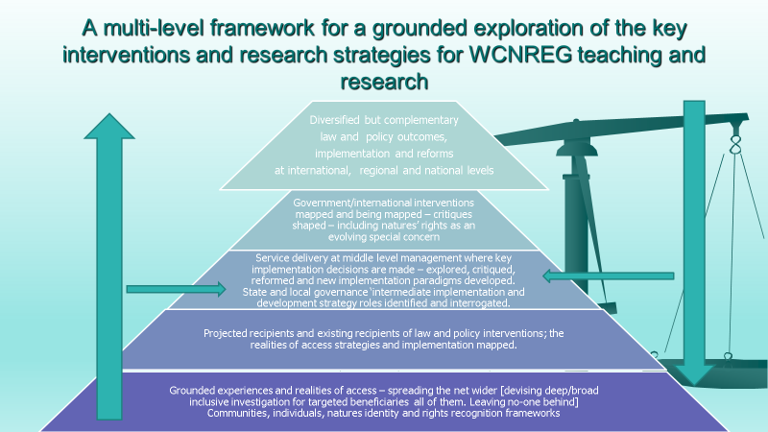

The framework for the methodology and project courses received general approval, particularly from former students on the SEARCWL programmes, as they appreciated how much they had benefited from these approaches.

Indigenous Knowledge and Customary Practices in Environmental Governance – under discussion! With or without Scientific Knowledge?

This course as envisaged will encompass the following:
Indigenous knowledge requires recognition, but it is local, needs responsive and is to be distinguished from scientific knowledge with which it is seen to be in competition.
Covers all forms of governance and identification of governance models wherever they are located.
Investigating customary and cultural practices that have been historically effective, but may be marginalized or trivialized, even criminalized and effect informed re-evaluation.
The need for exploration, facilitation and engendered approaches to indigenous knowledge and environmental governance was highlighted.
It was also seen as a quite likely research topic for some candidates but can be used as an early experiential individual research issue.
Harnessing diverse knowledge and management approaches that integrate and value traditional, customary and community based practical and practiced environmental management paradigms.
There are growing trend towards incorporating indigenous knowledge and management systems in environmental governance paradigms .
It was noted that there is an urgent need for Inclusive multi-level environmental governance structures that challenge stereotypical models and which decolonize approaches around environmental governance.
Overall, there was a positive approach to inclusion of indigenous knowledge and affirmation that it was justified in such a programme. There was a need to rationalize its content within clear incorporation and inclusion frameworks.
It was noted that there were innovative approaches to issues of environmental governance..

General Plenary- key issues raised after the presentations as a whole

- What would be the requirements for one to be admitted as a student?
Prof Stewart indicated that the University of Nairobi shall be handling all admission issues but it will most likely require at least a 2.1 undergraduate degree.
- A participant vehemently agreed that the Indigenous Knowledge course should not be combined with scientific knowledge/processes. Another participant concurred, stating that it is extremely important to diversify our knowledge base on indigenous practices as opposed to adopting foreign practices that may not work in a Zimbabwean context. She also stated that the prospect of the course is exciting.
- It was noted that there has been a change in the methodological approaches, evolving from the MSWL/MSLS Programme and that there is a new interesting addition to the top down and the bottom-up approach that is and meeting in the middle approach.
- The people working in the “middle component” for instance people working in local government, chiefs should be targeted as potential students to be included in the Programme. But also need to be research targets because of their key roles in implementation of environmental governance laws and policies.
- The inclusion of persons with disability was key and should clearly come out.
- There is use of words such as, rights, governance and implementation, there is also need to include key words such as peace building, resilience building in so far as women and children are concerned.

General Feedback- parting words from the stakeholders
- It is a very good programme, covering some cross cutting, issues of corruption, women’s rights as well as their access, control and ownership of resources.
- It is an exciting programme, maybe in the future consider joint offering of awards with the UZ and other universities in the consortium.
- I learnt a lot from the workshop as a non-lawyer, we have programmes such as this at community level but this would enhance our capacity, such as in programmes like “Agriculture for She” to empower female farmers, so I learnt a lot on the gendered dynamics in environmental governance.
- The issue of decolonizing the research and environmental governance is interesting and pertinent.
- Looking at diversity and intersectional approaches is critical as people tend to generalize the effects of Climate Change.
- Speaking on behalf of the Ministry of Women’s Affairs, the representative expressed profound gratitude to SEARCWL and funding partners for the opportunity to express views on the proposed curriculum.
- The programme is coming at a critical time when tensions between government’s stance/ policy on investment and local people protecting their local environment are at an all-time high.

Appendix 1 List of Participants

List of Participants

No. | Name of Participant | Organisation
 | Dr. Rosalie K. Katsande | SEARCWL
 | Prof. Julie Stewart | SEARCWL
 | Paidamoyo Mukumbiri | SEARCWL
 | S. Nyamutukwa | Ministry of Agriculture – Agritex Department
 | Mark Zvidzai | University of Zimbabwe
 | Delis Mazambani | Zimbabwe Human Rights Commission
 | Memory Chadambuka | One BW Exports SEARCWL graduate
 | Egline Tauya | UNICEF
 | Gracious Sinampande | Legal Resource Foundation
 | Hellen Venganai | Women’s University in Africa
 | Nesia C. Manguleni | Judicial Service Commission
 | Jameson D. Muleya | InterPol SARPCCO Centre SEARCWL graduate
 | Donnette R Chiduku | Outgoing SEARCWL student
 | Asdis Nina Magnusdettir | UNDP
 | Tinashe Chitunhu | Musasa Project
 | Henry Kachere | Ministry of Foreign Affairs
 | Tsitsi Zimoto | Zimbabwe Gender Commission
 | Webster Gumindoga | University of Zimbabwe – Department of Civil Engineering
 | Elizabeth Katumba | Ministry of Women Affairs, Community, Small and Medium Enterprise Development
 | Junior Muchuchu | Ministry of Women Affairs, Community, Small and Medium Enterprise Development
 | Samson Shumba | University of Zimbabwe – Construction and Civil Engineering Department
 | Nashima Mutara | Outgoing SEARCWL student
 | Veronica Zano | Oxfam
 | Martha Tarumbwa | Commercial farmer outgoing SEARCWL student/lawyer
 | Sandra Nhapi | City of Harare Water department outgoing SEARCWL student
 | Walter Kudanga | National Peace and Reconciliation Commission outgoing SEARCWL student

Appendix 2 – Gallery of Pictures

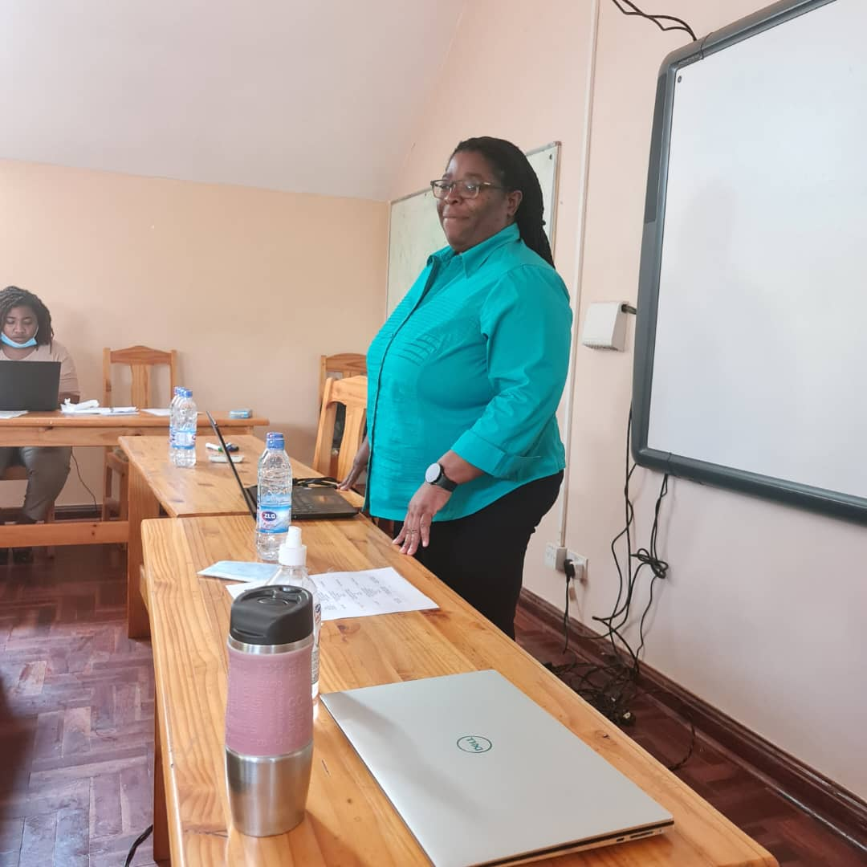
Dr. Katsande delivering opening remarks

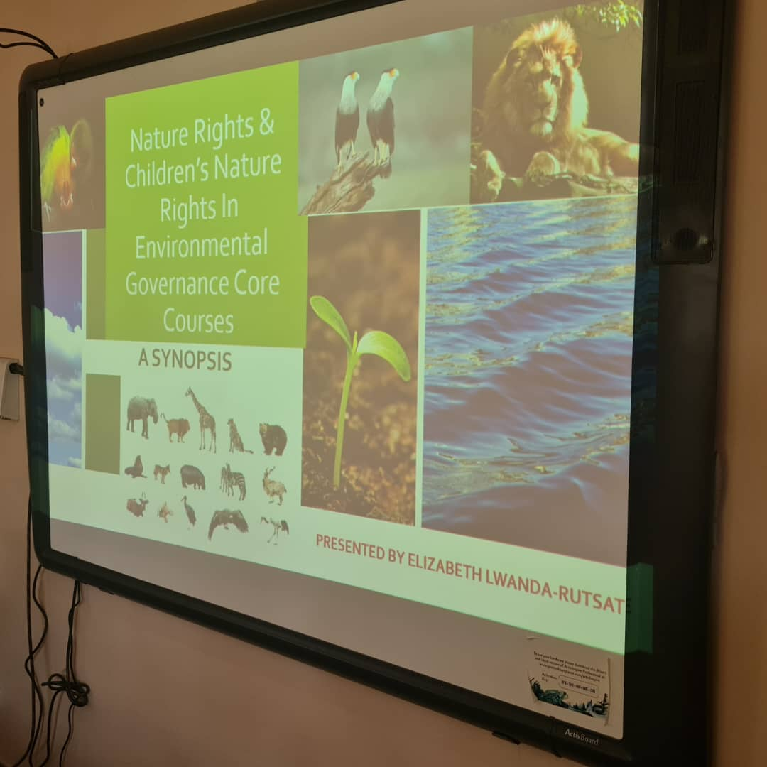
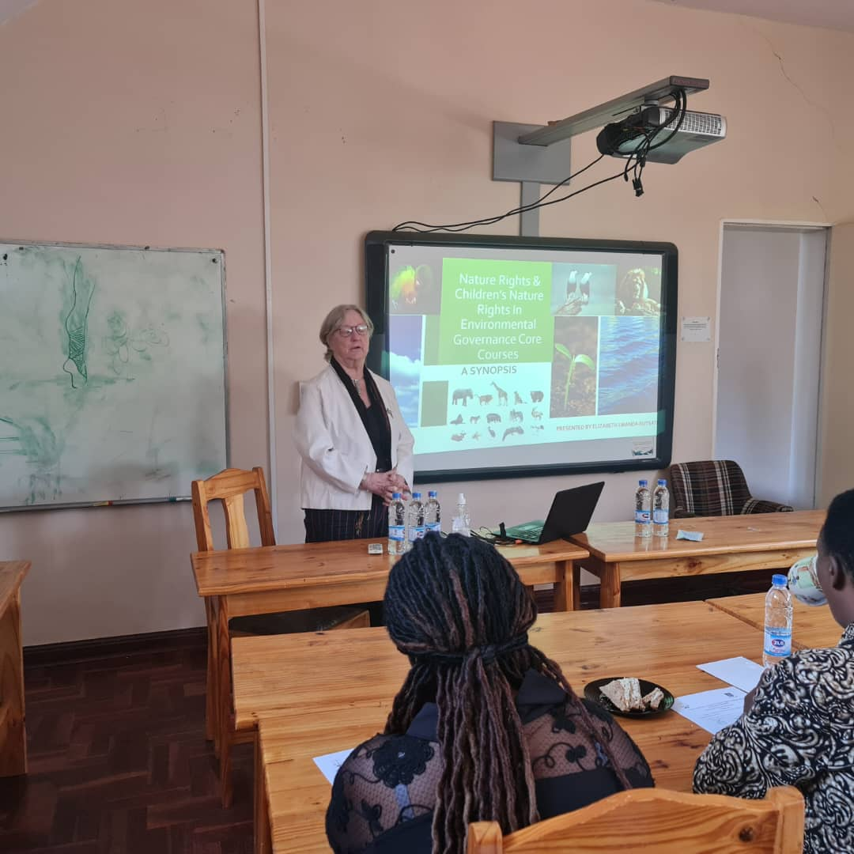
Prof J. Presenting on the Nature and Children’s Rights in Environmental Governance core modules

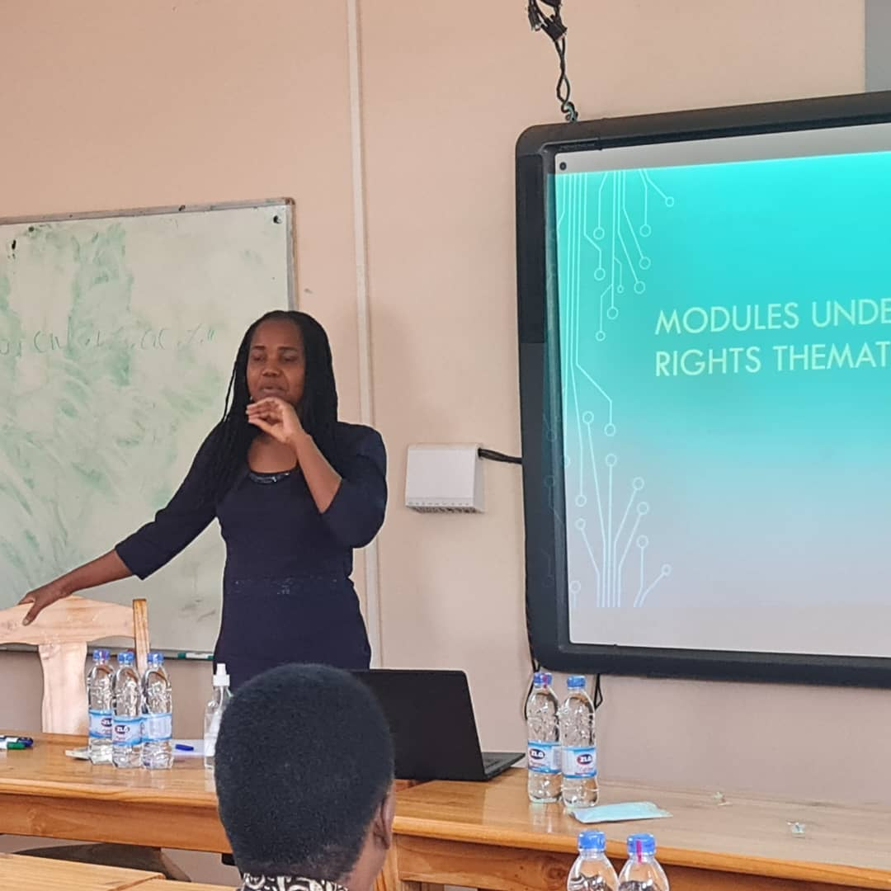
Ms. Mukumbiri presenting on the modules under the Women’s Rights in Environmental Governance thematic area.

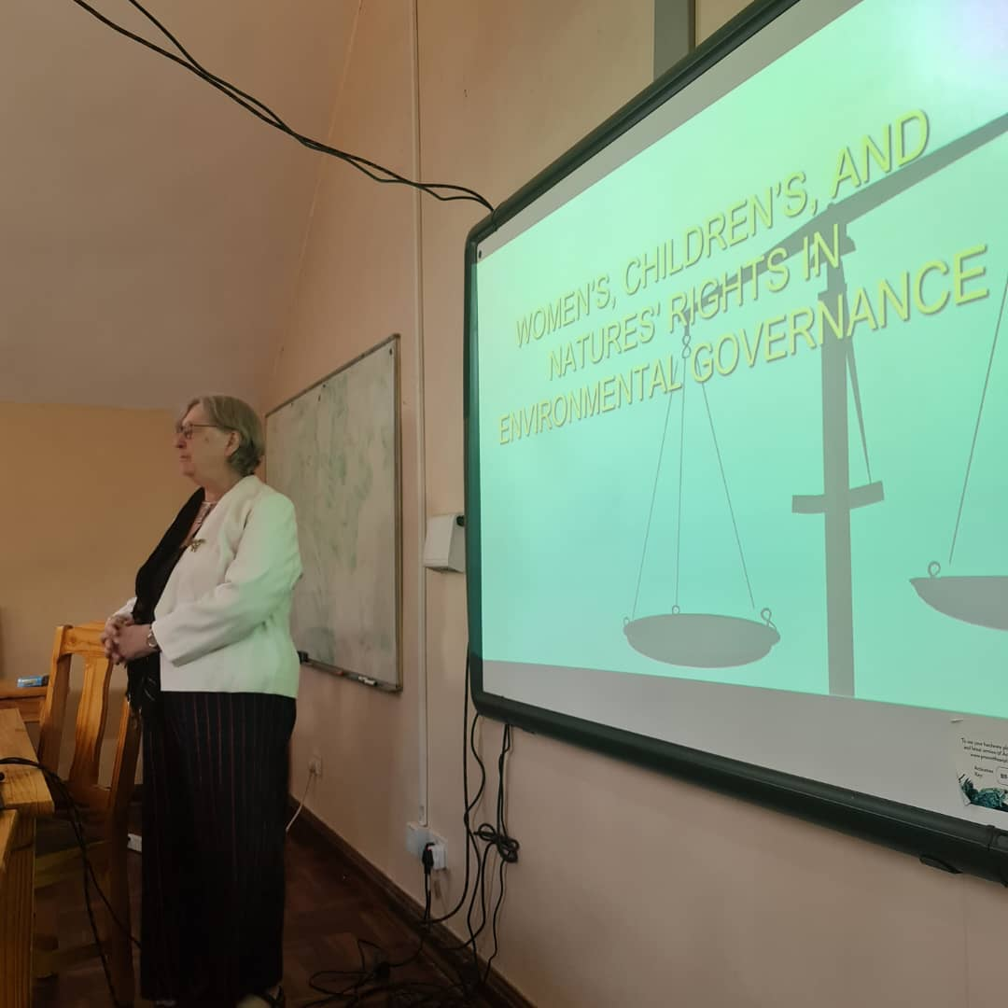
Prof Stewart presenting on the Advanced Methodology, Project Paper and Indigenous Knowledge in Environmental Governance

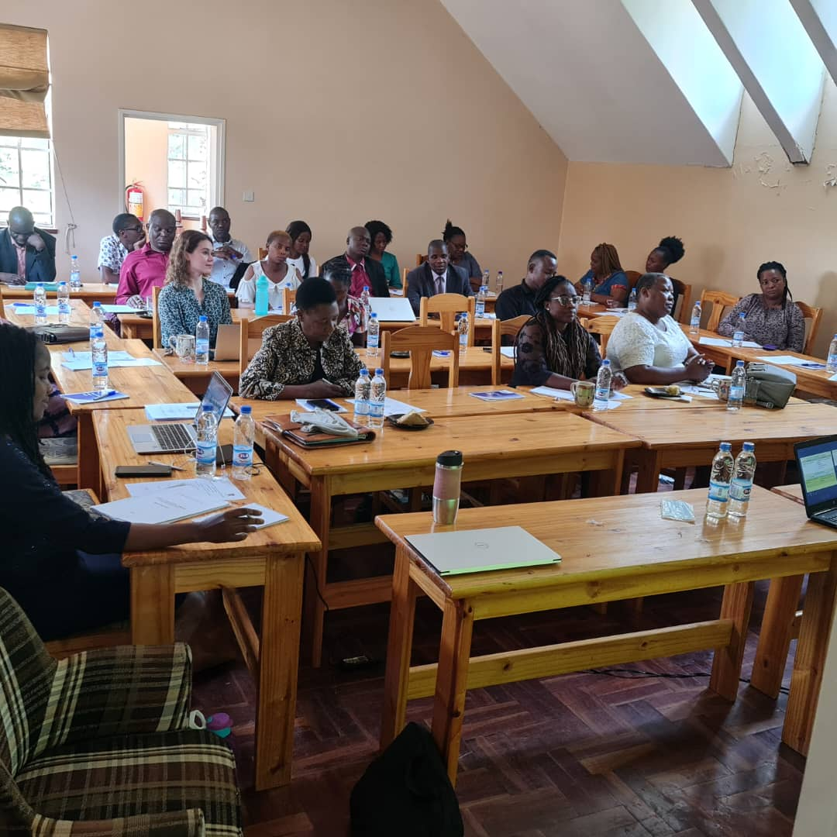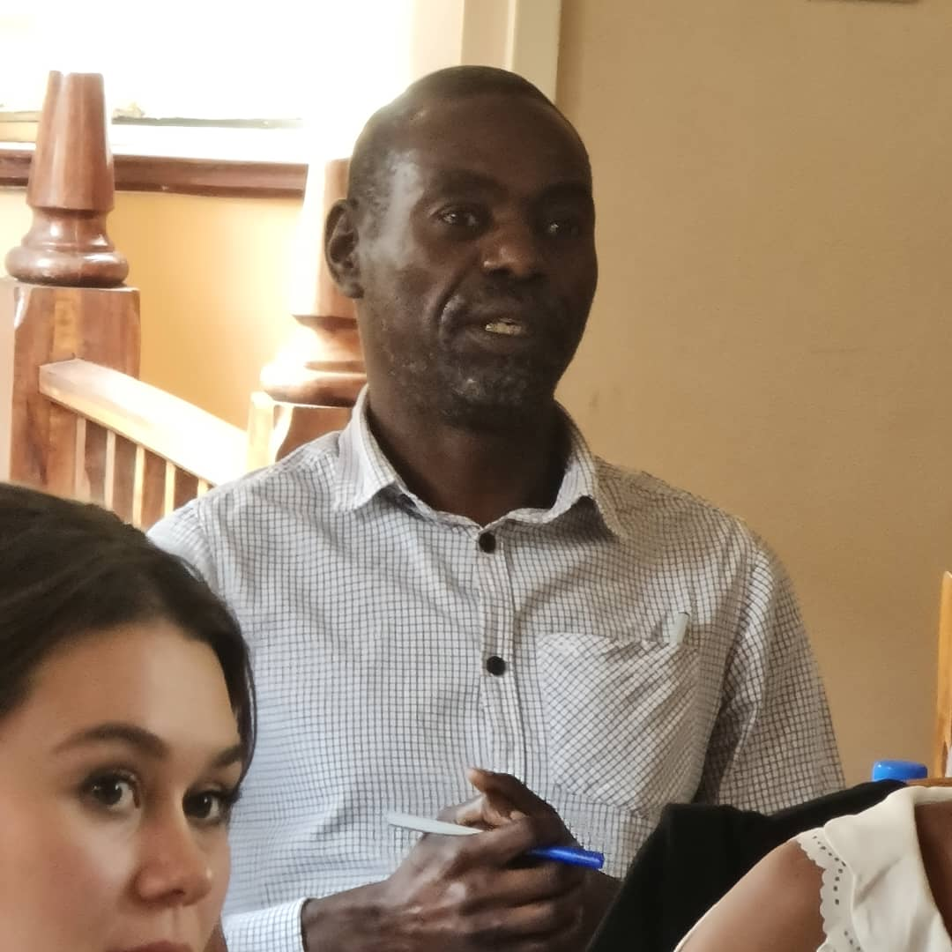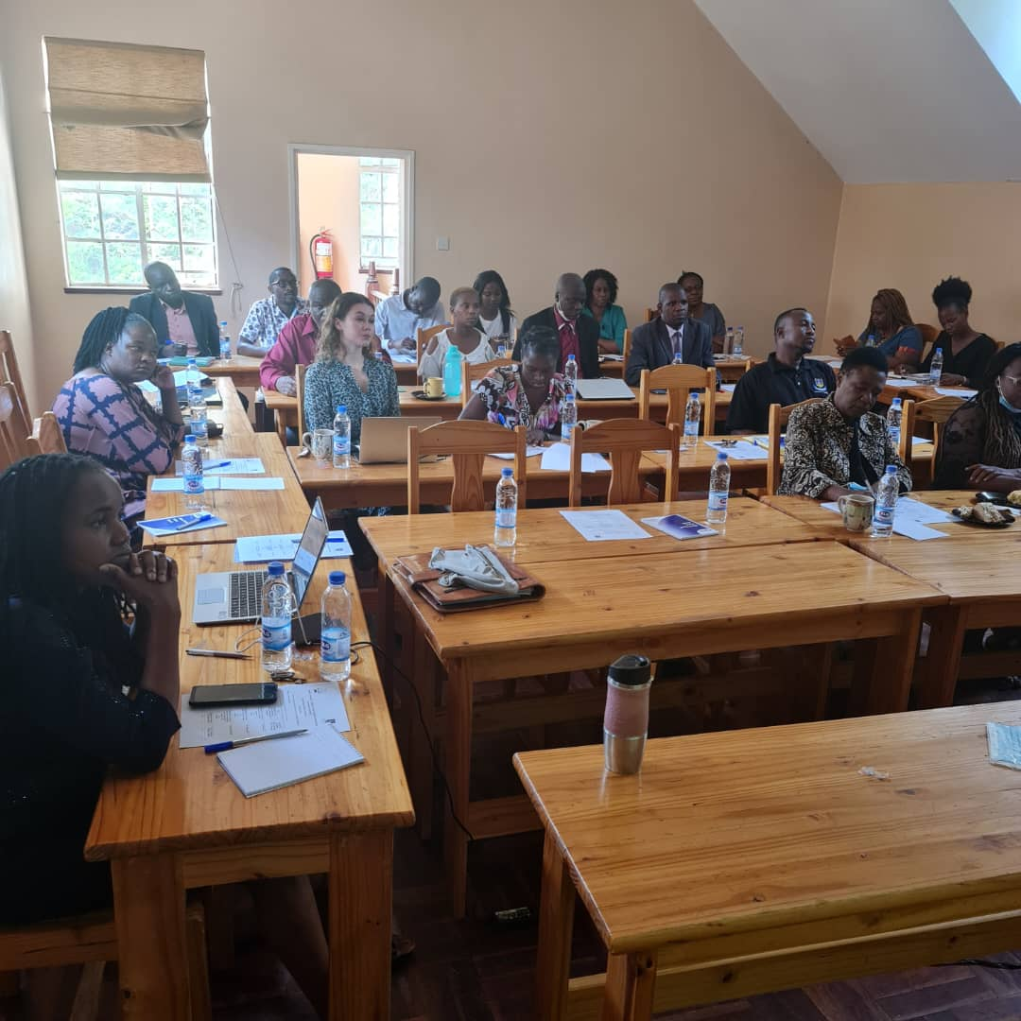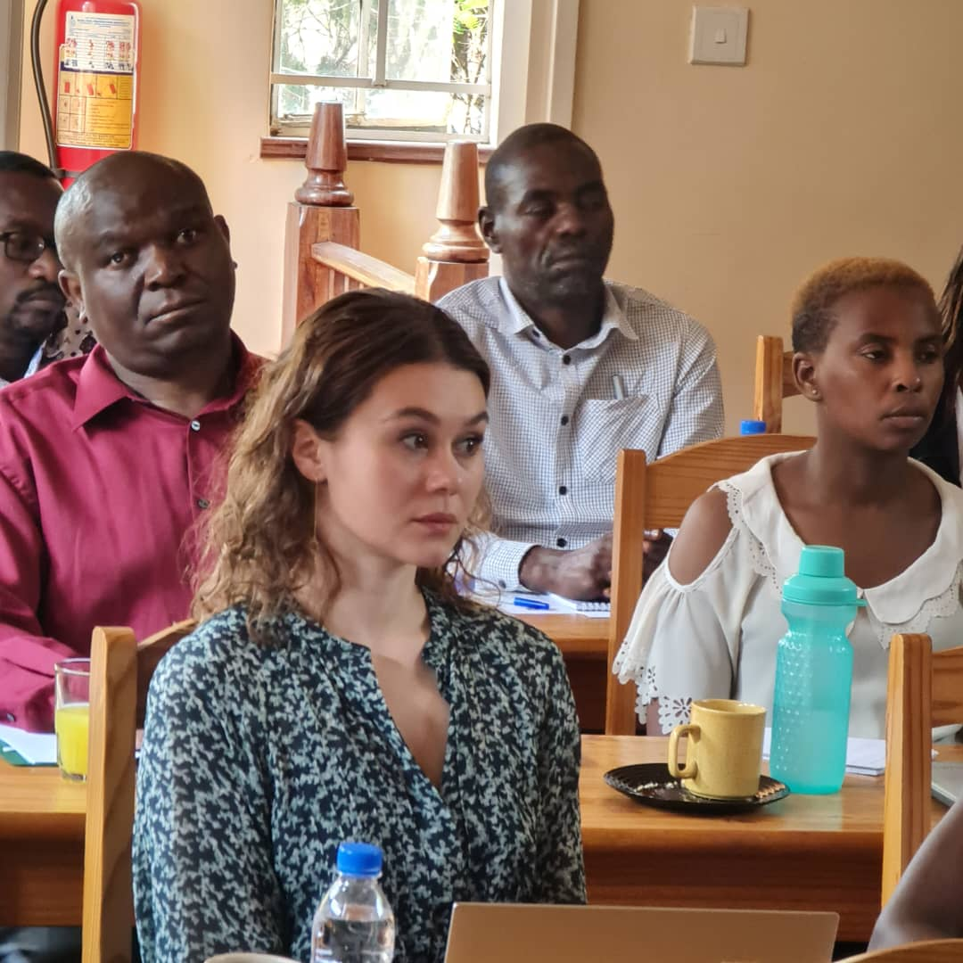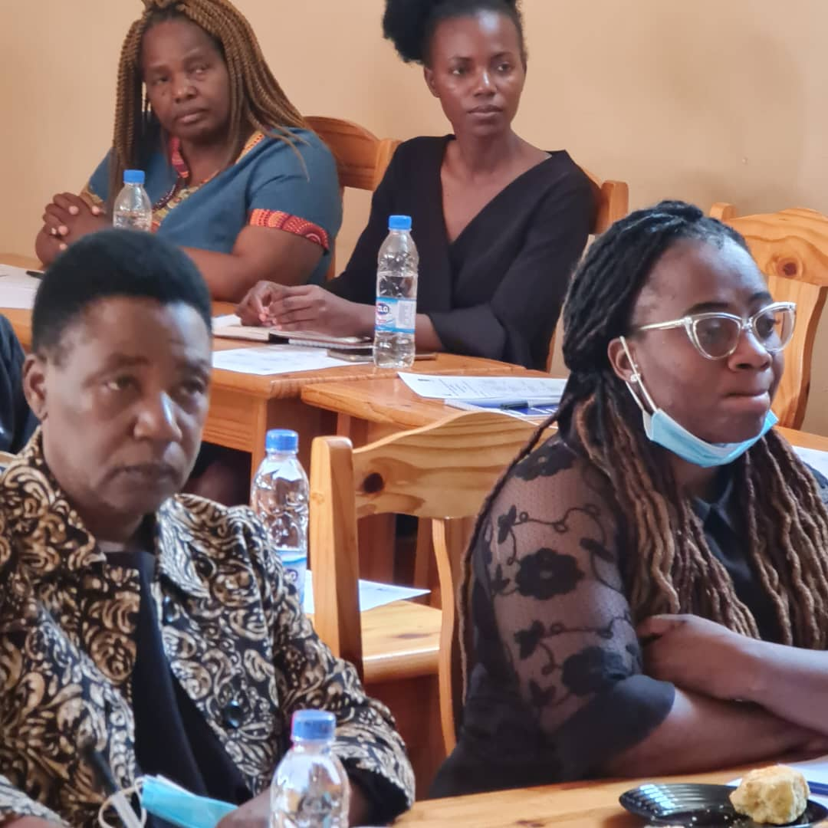
Multiple stakeholders and participants in the workshop

Although it was made clear that the workshop was directed at gaining affirmation of and new insights into the proposed programme prior to its processing via the University of Nairobi Academic Regulation processes and that the programme would be offered by UoN, some participants seemed to think it was Zimbabwe directed programme and would be in immediate effect.

