School of Law, Economics and Governance
NORHED WCNREG PROJECT

CURRICULUM DEVELOPMENT STAKEHOLDER CONSULTATIVE WORKSHOP

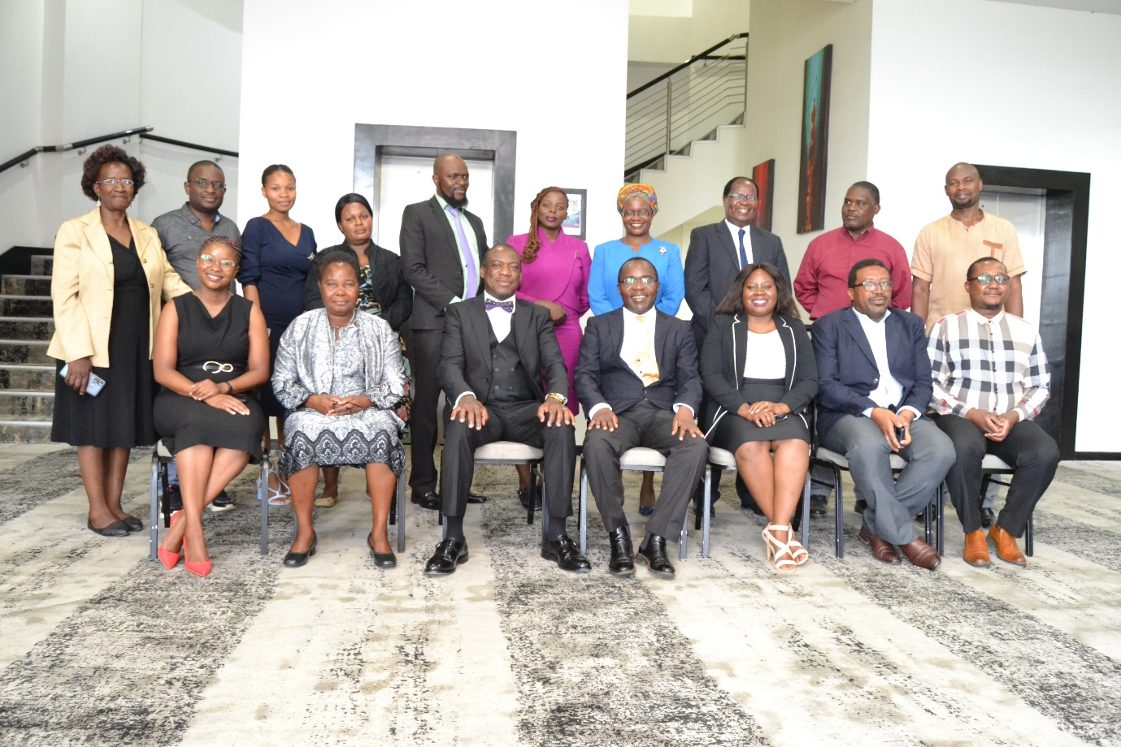

TUESDAY NOVEMBER 15, 2022
AMARYLLIS HOTEL
BLANTYRE

Table of Contents
1.0. Introduction 1
2.0. Stakeholder consultative workshop 1
2.1. Opening remarks 1
2.2. Curriculum Presentation 1
2.3. Curriculum review framework 2
2.4 issues discussed and raised regarding programme name/focus and requirement 2
2.5 Issues discussed and raised regarding modules 2
3.0. Conclusion 4
4.0. ANNEX A: Curriculum Development Stakeholder Consultative Workshop Attendances Register 5
5.0. ANNEX B: Curriculum Development Stakeholder Consultative Workshop Program 6

Introduction
The Faculty of Law (as was) after successfully implemented NORHED I Project under the theme “Masters, PhD and research programme for capacity building in law faculties to mainstream gender, non-discrimination, human rights and socio-economic rights frameworks and analysis into the application and administration of the law” has again received funding from the Norwegian Agency for Development Cooperation (NORAD) for the implementation of the NORHED II Project under the theme “Women's, Children's and Nature's Rights in Environmental Governance (WCNREG) Project”. The Project grant and implementation is with three partner institutions namely Faculty of Law (as was) now The School of Law, Economics and Governance of the University of Malawi, the University of Oslo (Norway), Faculty of Law of the University of Nairobi (Kenya), and Southern and Eastern African Regional Centre for Women's Law (SEARCWL) of the University of Zimbabwe. Thus, the Norhed WCNREG project is continuing implementing its activities as outlined in the project budget category. Recently, the project organised series of curriculum development research and in-house meetings to allow Law lecturers, academic staff from within School of Law, Economics and Governance and from outside to input in the curriculum development process towards the development of Masters in Women's, Children's and Nature's Rights in Environmental Governance (MA - WCNREG) curriculum together with partners institutions. Following from the in-house meetings, the project organised and implemented Curriculum Development Stakeholder Consultative Workshop on Tuesday, November 15, 2022 at Amaryllis Hotel in Blantyre. The objective of this consultative workshop was; to outline the curriculum framework for the purposes of the development of the MA - WCNREG curriculum. To review the draft curriculum and the draft course descriptions. To brainstorm on the structure, the content and program delivery of the WCNREG. Over and above the consultative workshop was aimed at giving stakeholders a platform to analyse, basing on their vast experience on issues that WCNREG program is tackling, and input in the curriculum. Approximately, 20 participants from various key institutions i.e. from academicians, activist, and key non-governmental organisations attended the consultative workshop.

Stakeholder consultative workshop

2.1. Opening remarks
The meeting commenced Professor Ngeyi Kanyongolo setting the conference agenda (see Annex B), this was followed by welcoming remarks by Sunduzwayo Madise (Deputy Vice Chancellor of the University of Malawi). Then the Prof. Happy Kayuni (the Acting Executive Dean of School of Law, Economics and Governance) gave his welcoming remarks and gave an overview of the importance of WCNREG curriculum Development and stakeholders input (see-attached pictures below).

2.2. Curriculum Presentation
After the remarks, then Mr Chikosa Banda and Dr N. Mweso co-presented the draft WCNREG curriculum highlighting the following:
- Nature of programme including admission requirements and target group
- Philosophy
- Rationale
- Goal
- Learning outcomes
- Modules
- Structure
The participants were provided with a summarized version of the modules to be offered.

2.3. Curriculum review framework
Professor Garton Kamchedzera facilitated division into five groups with each group have an assigned section of the draft curriculum document content to review based on expertise. He presented a framework for review that included consideration of the following factors:
- relevance
- feasibility
- rigor
- international competitiveness and
- sustainability

2.4 issues discussed and raised regarding programme name/focus and requirement
- Environmental ethics is missing or nor evident in the programme- why is this the case?
- The programme needs to highlight or focus on the environmental benefits- this seems to be missing too in the programme
- The programme is focusing on women and not gender- why? Gender is more encompassing and broad
- Men’s role in nature has been left out
- Entry qualification might lead to targeted group being left out as it is restrictive to lawyers only, why?

2.5 Issues discussed and raised regarding modules

Livelihoods, Environmental protection, and climate change –
- This is relevant especially in relation to agriculture and fishing industry, especially for a country like Malawi which heavily depends on environment for livelihoods as such it essential to include these issues in environmental governance
- The group also agreed that this curriculum component is feasible.
- On rigor, the group established that there is a need to include more high-level learning outcomes or indicative content highlighting community centric, proactive strategies, promotional of sustainable livelihoods. Also a component on understanding different approaches of livelihood promotion.
- The group also agreed that this curriculum component is of international competitiveness and sustainable.

Marine and Aquatic Environment –
- This component is relevant to the in the context of Malawi as most people depend on it for livelihood. However, there is a need to consider adding rights of International and trans-boundary and riparian aquatic environment such as Songwe, Shire and Zambezi shared watercourses.
- As it is, there is too much emphasis of international environment. This component if feasible and the draft curriculum document thoroughly addressed specific issues in line with this curriculum component. Additionally, this component has in it, aspects of international competitiveness and sustainable,

Gender, Generational and Environmental Justice –
- As it is, this curriculum component is relevance, feasibility, rigor, international competitiveness, and sustainability. It can easily be called as owner of programme since “gender” covers wider aspect rather than specifically indicating women only.
- Should include the role of men in nature. Men being environmental hazards

Health & Environment –
- As it is, this curriculum component is relevant, relevance, feasibility, rigor, international competitiveness, and sustainability.
- There is a need to reconsider focus to include more on animal health.

Child’s Rights in Environmental Governance (WCNREG004) -
- The group found both the module to be relevant and feasible.
- .
- In addition, the group notices that when examining environmental governance from a ‘child-centered lens’, there is a need to consider the diversity amongst the children and inclusion. Also take into consideration the ages, gender and also consider the ‘youths’.

Nature’s rights in environmental governance and Soil and land governance –
- The group noted that for a Master program, this component shows its relevance, feasibility, rigor, international competitiveness, and sustainability. However, this component is too loaded, there is a need to consider if all these issues would delivered within allocated time.

Women’s rights in environmental governance –
- It was established that the module meets all criteria for review.
- It was pointed out that when exploring women’s agency, autonomy and their rights to a healthy environment and participation, developers or module delivery should remember to consider diversity existing amongst the group. It should include national and local level diversity of a woman e.g. single mothers, disabled, and working-class women etc.
- Take into consideration the plight of the marginalized groups women i.e. the ultra-poor, single/ widowed, those with special needs, HIV/AIDS etc
- Additionally, members inquired as to why the program specifically mention women and not gender because “gender” covers everybody?
- Men’s role in nature has been left out – the program needs to bring that out because men are the ones on the forefront contributing to environmental degradation

Children rights in environmental governance –
- The group noted that for a Master program, this component shows its relevance, feasibility, rigour, international competitiveness, and sustainability. There is a need that this component should consider age and diversity among them boy child should be included.

Advanced research methodology –
- The group noted that for a Master program, this component shows its relevance, feasibility, rigor, international competitiveness, and sustainability. However, the course should critically be upgraded with higher learning outcomes and content and not sound as an introductory course. The wording needs to be changed to show this.
Biodiversity
- It was established that the module meets all criteria for review
- It is broad and needs to narrow down. Should be renamed as sustainable biodiversity management

Indigenous knowledge and customary practice in environmental governance –
- The group noted that for a Master program, this component shows its relevance, feasibility, rigor, international competitiveness, and sustainability. It should also include scientific knowledge as well

Conclusion
The Acting Executive Dean of School of Law, Economics and Governance thanked all participants for making time to input in the MA – WCNREG draft curriculum and further assured participants that inputs will be integrated in the draft curriculum and that participants are free to email additional information relevant to the curriculum development. The Curriculum Development Stakeholder Consultative Workshop was conducted successfully as participants actively engaged and contributed to the curriculum. Some invitees however did not come to the workshop even after confirming attendance.

ANNEX A: Curriculum Development Stakeholder Consultative Workshop Attendances Register
No | Name | Institution | Position | Contacts
1 | Ngcimezile Mweso | Unima | Norhed Project Coordinator/Law Lecturer | mweso@unima.ac.mw
2 | Bernadete Malunga | Unima | Norhed Projecr/ Law Lecturer | bmalunga@unima.ac.mw
3 | Happy Kayuni | Unima | Acting Executive Dean SLEG | hkayuni@unima.ac.mw
4 | Chikosa Banda | Unima | Senior Lecturer | cbanda@unima.ac.mw
5 | G. Kamchedzera | Unima | Ass. Professor of Law | gkamchedzera@unima.ac.mw
6 | John Njalam’mano | MUST | Lecturer | jnjalammano@must.ac.mw
7 | Agness Napwaya | Ministry of Gender | DGDO | agnapwaya@gmail.com
8 | Sophie Nambuzi | Ministry of Agriculture | PARS | sophienambusi@yahoo.cpm
9 | Ngeyi Ruth Kanyongolo | Unima | Ass. Professor of Law | nkanyongolo@unima.ac.mw
10 | Sunduzwayo Madise | Unima | Deputy Vice Chancellor | smadise@unima.ac.mw
11 | Samuel Kaphuka | Unima | Head Foundational Law | skaphuka@unima.ac.mw
12 | Tamara Nthara | MUST | Lecturer | tnthara@must.ac.mw
13 | Daniel Mwakaweka | Action for Environment Sustainability | Coordinator | mwakaweka@gmail.com
14 | Enoch Chilemba | Unima | Senior Lecturer | echilemba@unima.ac.mw
15 | Wyson Kwatani | CONGOMA | Coordinator | wysonkwatani@gmail.com
16 | Loveness Musiyapo | Unima | Lecturer, School of | lmsiyapo@unima.ac.mw
17 | Gloria Majiga | CEPA | Programs Manager | gloria@depa.org.mw
18 | S. Banda | Unima-Accounts | SAA | sonpowellbanda@yahoo.com
19 | Dorea Mwale | Unima | Secretary to AED-SLEG | dmwale@unima.ac.mw
20 | Chililo Gondwe | Unima | Project Manager | Cgondwe@unima.ac.mw
21 | Wezzie

ANNEX B: Curriculum Development Stakeholder Consultative Workshop Program
SCHOOL OF LAW, ECONOMICS AND GOVERNMENT

WOMEN’S, CHILDREN’S, AND NATURE’S RIGHTS IN ENVIRONMENTAL GOVERNANCE (WCNREG)

Curriculum Development Consultation Workshop Program
15th November 2022
Amaryllis Hotel, Blantyre
REVIEWING THE WNCREG DRAFT CURRICULUM
FACILITATOR: Prof. Garton Kamchedzera
TIME | TOPIC | RESPONSIBLE PERSON
8:45 - 9:00 am | Arrival and Registration | Secretariat
9:00 - 9:10 am | Setting the Agenda | Prof. Ngeyi Kanyongolo  Deputy Head, Legal Studies
9.10 – 9.20 am | Opening Remarks | Prof. Happy Kayuni  Acting Executive Dean, LEG
9:20 - 9:30 am | Welcome Remarks | Dr. Sunduzwayo Madise  Deputy Vice Chancellor
9:30 - 10:15 am | Presentation of the Draft WCNREG Curriculum | Dr. Ngcimezile Mweso  Mr. Chikosa Banda
10:15 - 10:30 am | Division into thematic groups  Group photo | Prof. Garton Kamchezera
10:45 – 11:45 am | Working in Groups | All
11:45-12:30 pm | Interactive Plenary | All
12:30 pm | Conclusion & Vote of thanks
12:35 PM LUNCH & DEPARTURE

Annex C: Professor Happy Kayuni - Acting Executive Dean of School of Law, Economics and Governance welcoming remarks

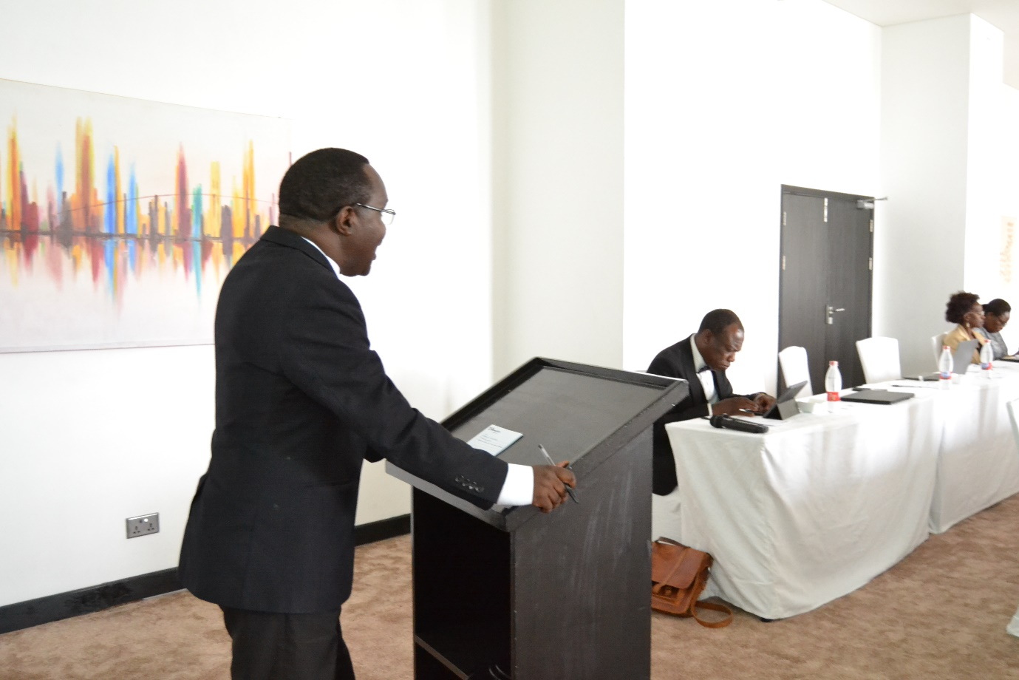

Annex D: Dr Sunduzwayo Madise (Deputy Vice Chancellor) giving his welcoming remarks

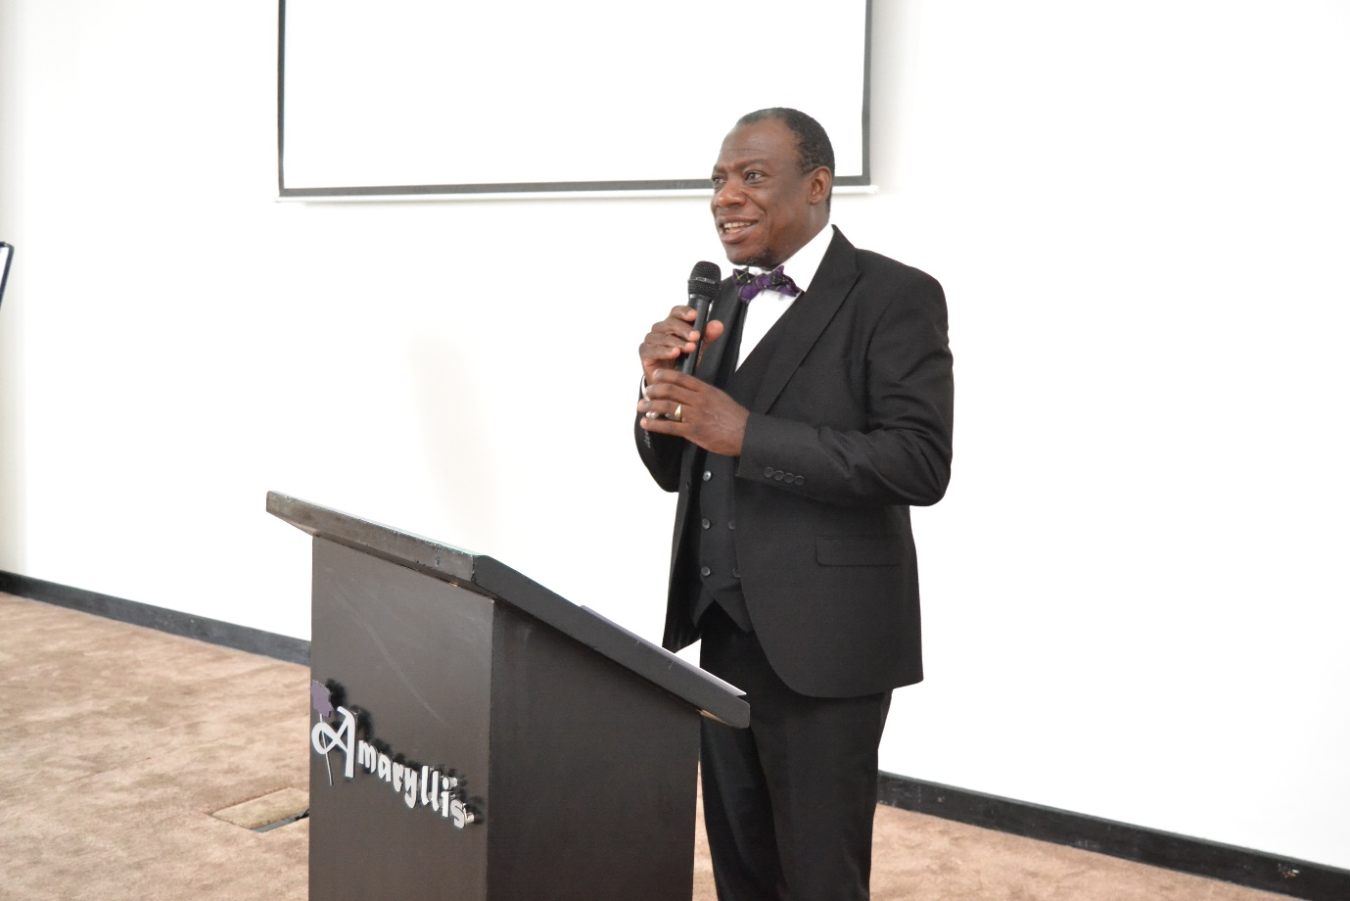

Annex E: Professor G. Kamchedzera explaining to participants before breaking into groups
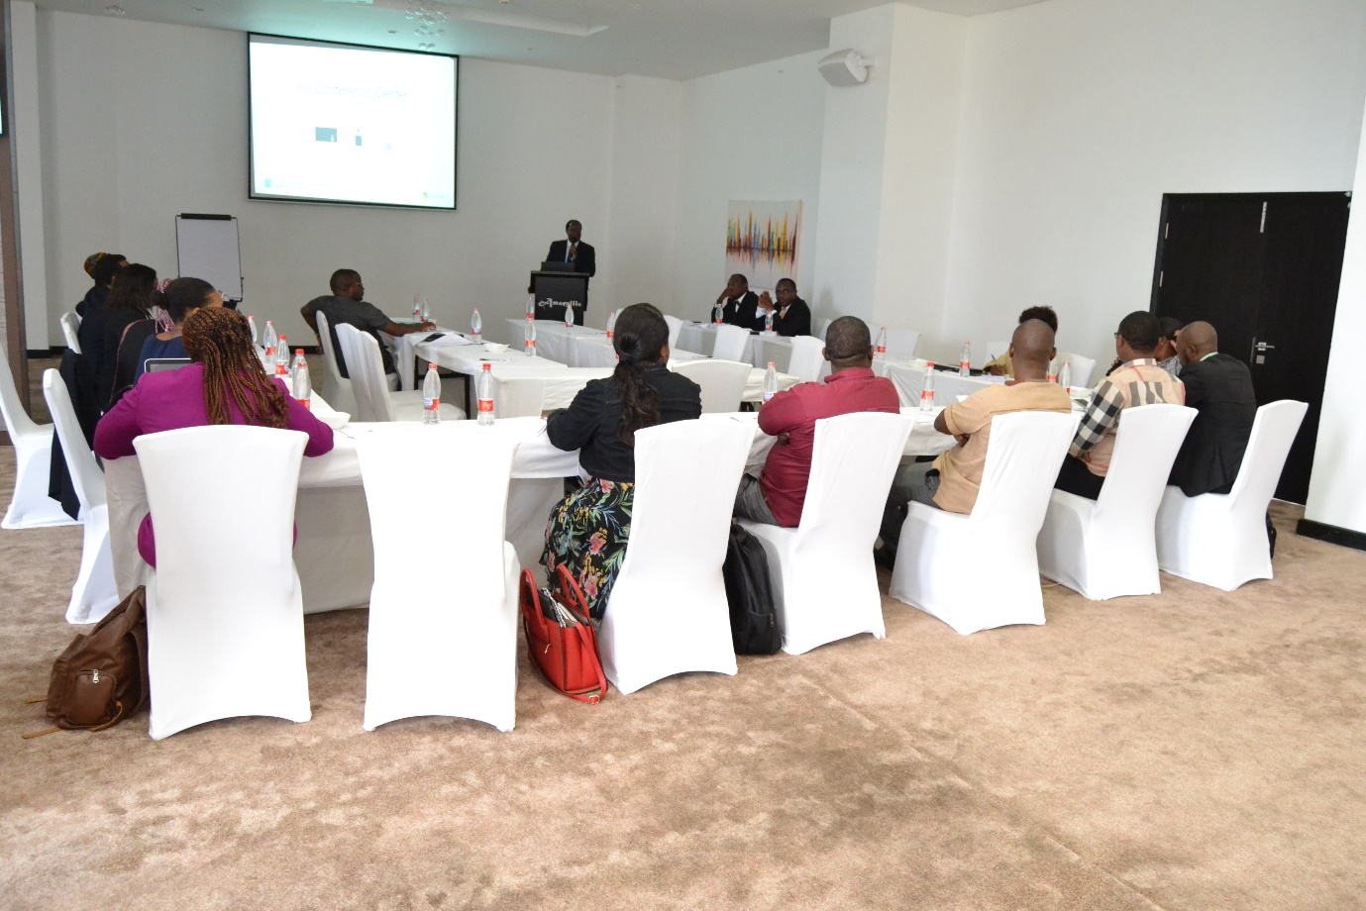

Annex F: Participants working in groups with UNIMA staff as group secretaries 